|  |  |
| --- | --- |
|  | **HC Ice Hockey Fundraiser** |

Let's raise some dough for HC Ice Hockey!

Never tried Krispy Kreme before...  Not near a Krispy Kreme location...

We've got you covered!

Preorder a box of doughnuts (one variety per dozen) for $15 each.

12 oz. bags of coffee for $10 each.

Place your order by Wednesday, Feb 1st. We'll distribute the doughnuts and coffee during the Thursday, Feb 9th practice between 3-5pm @ FIA.

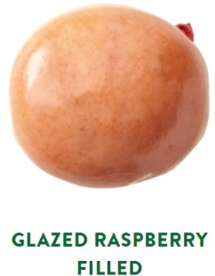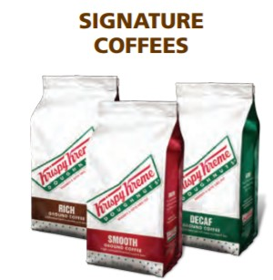

**Name**: _______________________________ **Phone #**: ____________________

|  |  |  |  |
| --- | --- | --- | --- |
| **Quantity** | Item | Price Per | **Total Per Item** |
|  | Dozen Original Glazed | $15 |  |
|  | Dozen Chocolate Iced | $15 |  |
|  | Dozen Lemon Filled | $15 |  |
|  | Dozen Raspberry Filled | $15 |  |
|  | Dozen Kreme Filled | $15 |  |
|  | 12 oz. Smooth Coffee | $10 |  |
|  | 12 oz. Decaf Coffee | $10 |  |
|  |  | **Order Total** |  |

Payments:

- Venmo: **@Deirdre-Meyer-5**

- Cash/check payable to **HCRHS Ice Hockey Booster Club**.

Completed form should be given to Deirdre Meyer or Lynn Flynn.